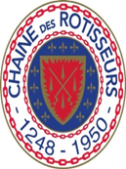

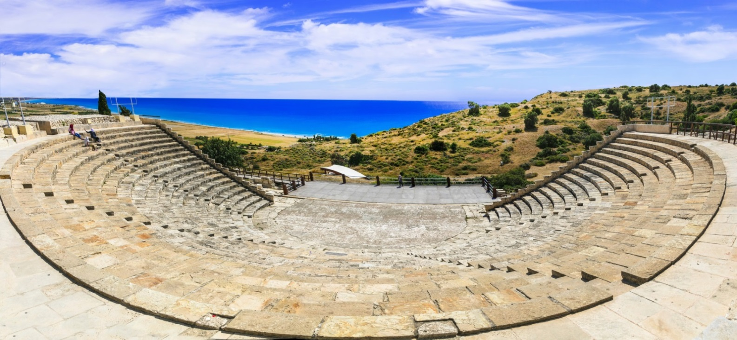
Confrérie de la Chaîne des Rôtisseurs,
BAILLIAGE NATIONAL DE CHYPRE
20th Anniversary GRAND CHAPITRE
Limassol, October 16, 17, 18, 2020
Email: info@chainecyprus.com

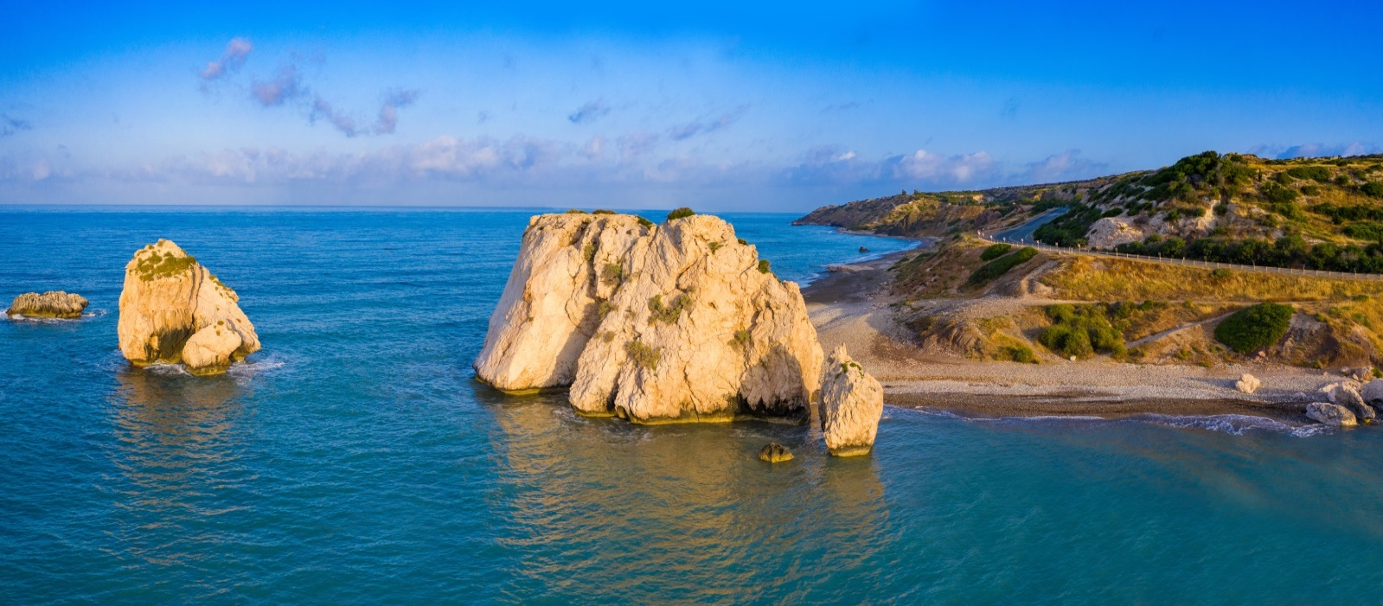
Birth place of Aphrodite
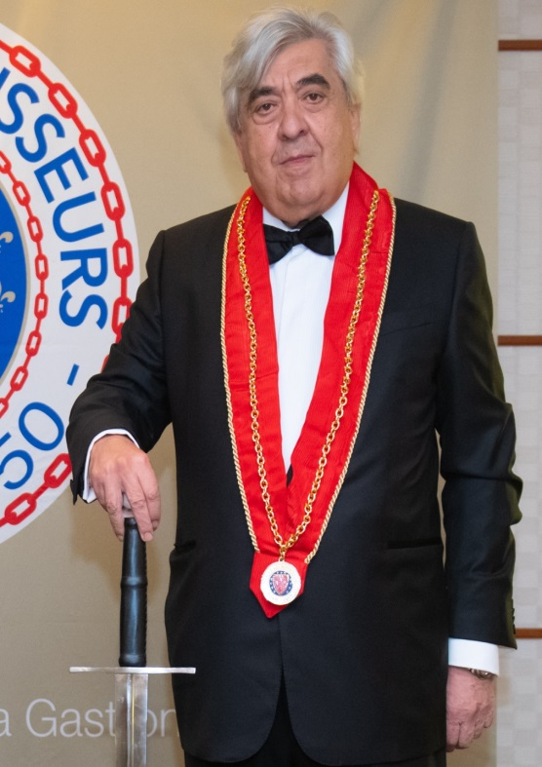
Chers Confrères, Chères Consœurs,

It is with much pride and pleasure that our Bailliage invites you to join us in celebrating the 20th anniversary Grand Chapitre in Cyprus.
The event will be held from 16th to 18th October 2020 in Limassol and its surrounding areas to ensure we can blend our common passion for fine cuisine with Cypriot specialities and hospitality. The close proximity of unique archeological and historical sites will enable you to combine the best of both worlds to make your visit a memorable one.
Our organizing committee has carefully created a program of events to ensure you can enjoy such pleasures with the very least of effort. Given our Bailliage΄s rich multinational membership you are almost certainly going to find a lot more in common with us than the pleasures of the table!
It is an honour for us that Mrs Marie Jones, the International Vice-President, will be presenting the Induction Ceremony.
Vive la Chaîne!
Victor Papadopoulos
Bailli Délégué,
Membre du Conseil Magistral

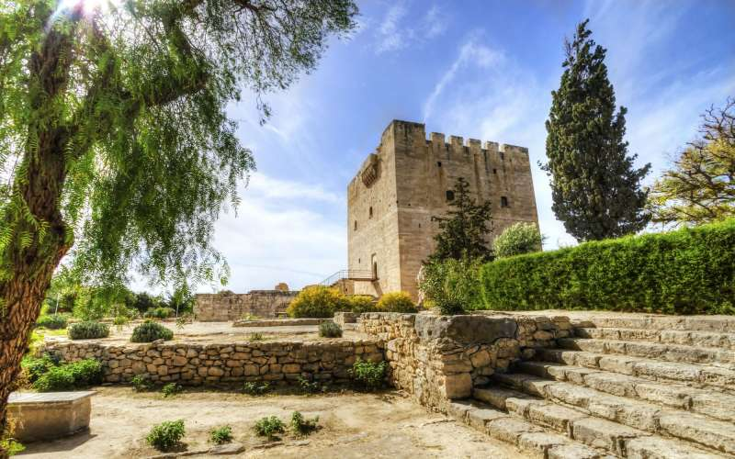
WINDOW ON CYPRUS
Although the Bailliage is relatively young in age, the country has to offer remains of a very long history. It’s name seems to derive from the metal copper (Kypros in Greeek), which was found plentiful and widely exported.
The oldest found, some figures in stone, date back to 7000 B.C. Given the long history, the island had been part and influenced by all main cultures of the region, be it the Phoenicians, the Egypt of the Pharaohs, Hellenism, the Roman Empire of Byzantine. Within about the last 1000 years, after captured by King Richard the Lionheart, Cyprus had been ruled by the French House of Lusignan, the Venetians, the Ottomans and the British, before reaching independence in 1960.
They all left their mark on the island, of which many are still part of the cultural heritage of Cyprus. The goddess Aphrodite according to mythology has ascended from the sea close to Paphos. The beautiful place and some remains of her temple nearby can still be seen. Artefacts of the Roman period are plentiful, be it mosaics on floors or temples, potteries in all forms as well as cups and vases of glass. Christianity has developed in Cyprus at a very early stage, founded by Saint Barnabas at the beginning of the first century. The presence has been undivided strong till today and plenty of small churches and chapels with remarkable frescos from the 12th-15th century are still in use and can be visited. Several of the Roman and Christian cultural witnesses have been enlisted in the UNESCO world heritage, together with the archaeological excavation site Chirokitia dating from the New Stone Age.
Despite being influenced by so many cultures, till today Cyprus has stuck to Hellenism. It seems, a strong impact leads back to the time when after the Trojan War many of the Hellenic heroes decided to settle on the Island and started an active life here. A visit to the island is somewhat also a return to the fundaments of European culture.

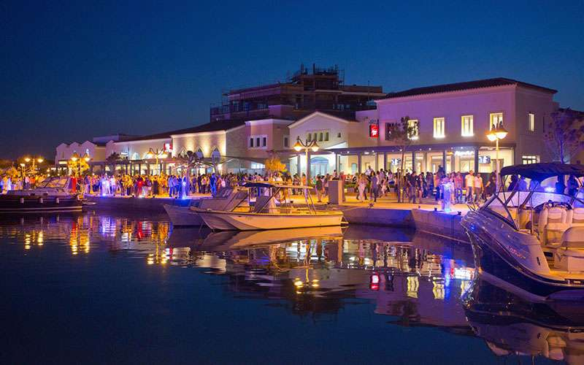
TROODITISSA MONASTERY FRIDAY 16TH OCTOBER 2020
Located on the southern slopes of the Troodos mountain range, the 13th century Trooditissa Monastery is situated among pine trees, commanding a picturesque spot. The present church was built in 1731 and contains a priceless silver-leaf covered icon of the Virgin Mary brought from Asia Minor, believed to give childless couples hope if they pray to her.
The exact date of the foundation of the monastery is not known, but it is believed to have been established immediately after the iconoclastic era by a hermit who resided there during the years of the iconoclasm. The church, as well as the monastic building, belong to a later period and can be dated to the end of the 18th or the 19th and 20th centuries.
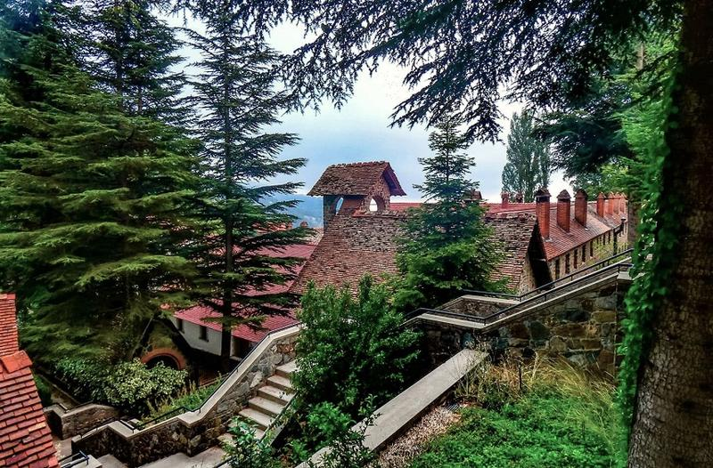
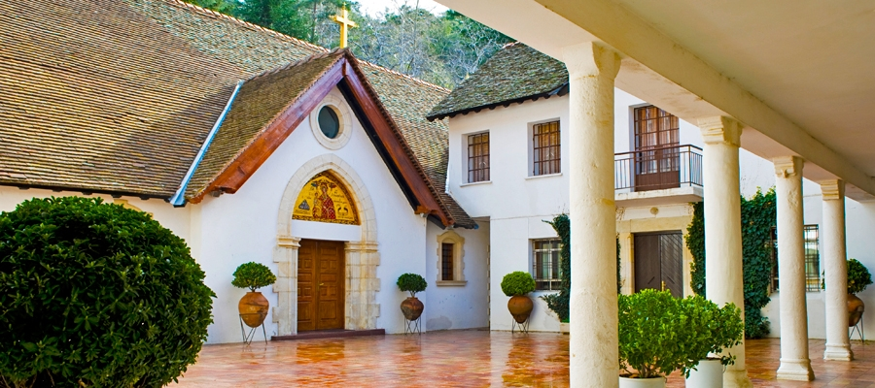
ANCIENT KOURION SATURDAY 17TH OCTOBER 2020
Ancient Kourion (or Curium) was a major center of cultural, political and religious life. It was home to the centuries-old site of the Sanctuary of Apollo and later the seat of a Christian bishop. It is located on one of the most fertile spots on the island, with extensive ruins that include well preserved mosaics. Also of interest are the Public Baths, the Nympaeum, the Necropolis, the Fountain House, the House of Gladiators and the House of Achilles. The most spectacular site at Kourion is the Greco-Roman theatre, or forum, that has been completely restored and is used today for open air musical and theatrical performances
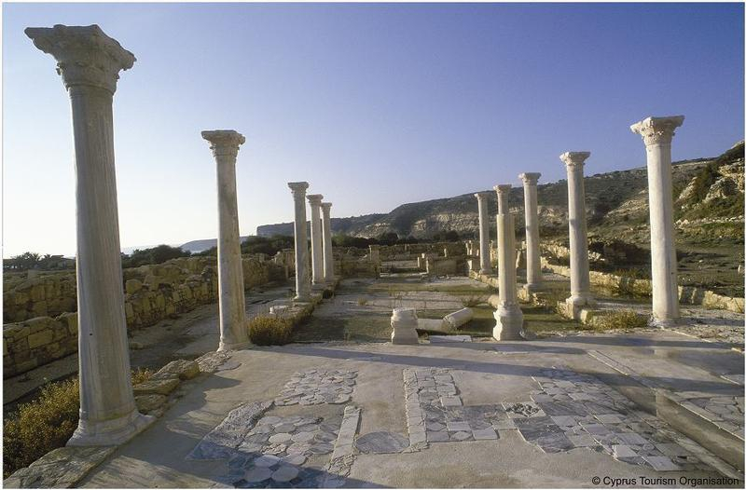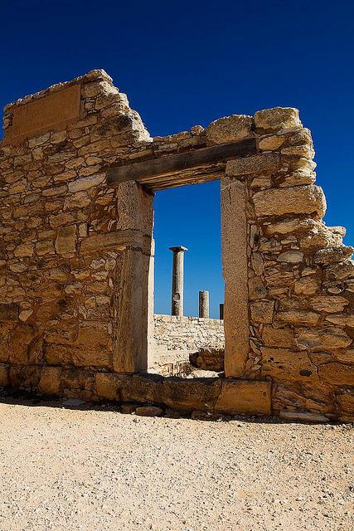
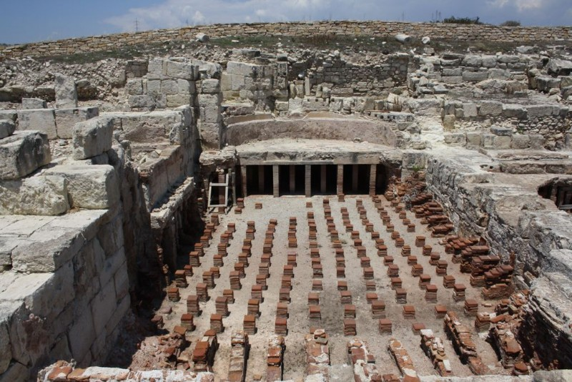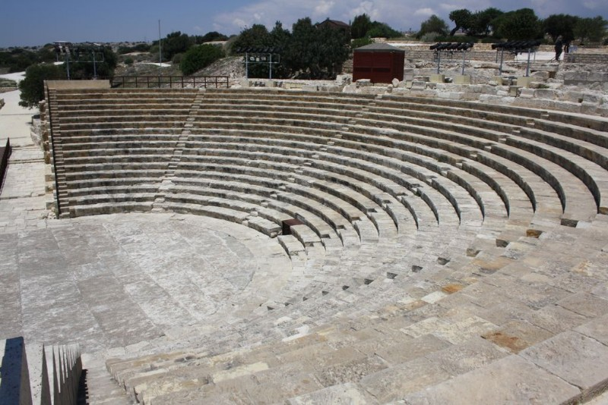

PAPHOS MOSAICS SATURDAY 17TH OCTOBER 2020
Located in the Kato Paphos region of Cyprus, the ancient floor mosaics are considered amongst the finest in the world, serving as a valuable and beautiful record of everyday life of the Greco-Romans as well as the legends of gods, goddesses, and heroes. Visitors cannot fail to be astounded by the quality of them, particularly the later ones.
Floor mosaics were an important component of houses and palaces of the elite in antiquity. Discovered by archaeologists as recently as the 1960s, the mosaics that remain today are from houses of different eras between the second and fourth centuries CE , beginning with the Hellenistic period and extending until the Byzantine era.
Though a large number of houses and the mosaics within were destroyed over the centuries, five houses with large sections of mosaics with varying levels of damage can be seen at Paphos. The mansions are named after the recurring theme found in the mosaics inside: the House of Dionysus, the House of Theseus, the House of Aion, the House of Orpheus, and the House of The Four Seasons.
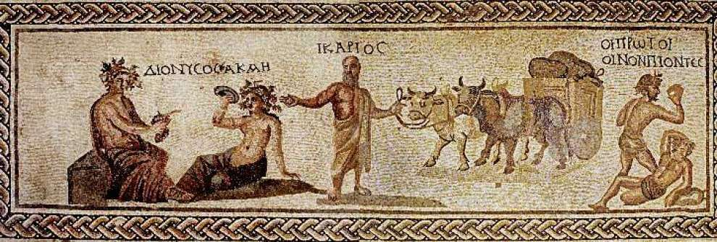. 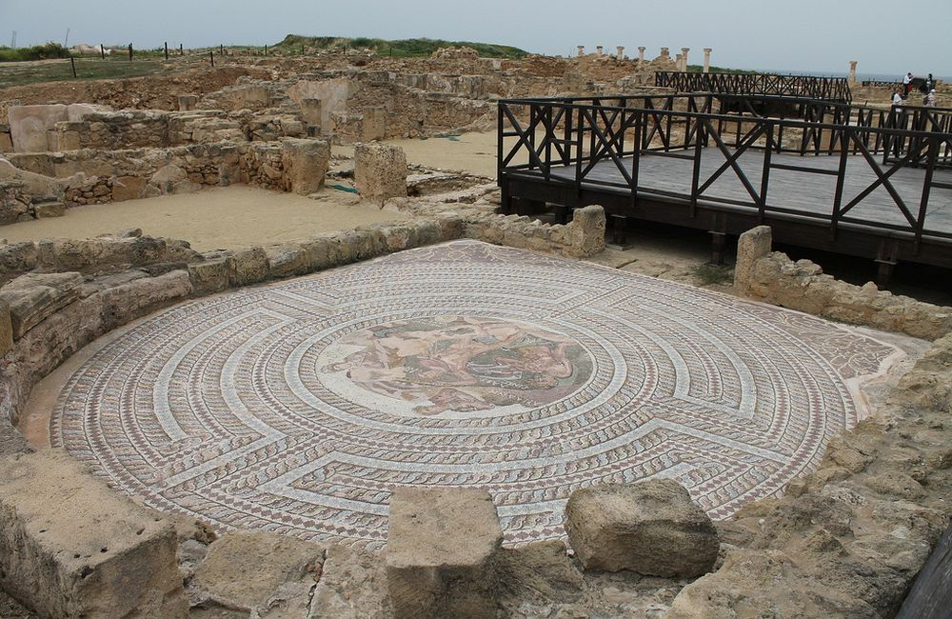 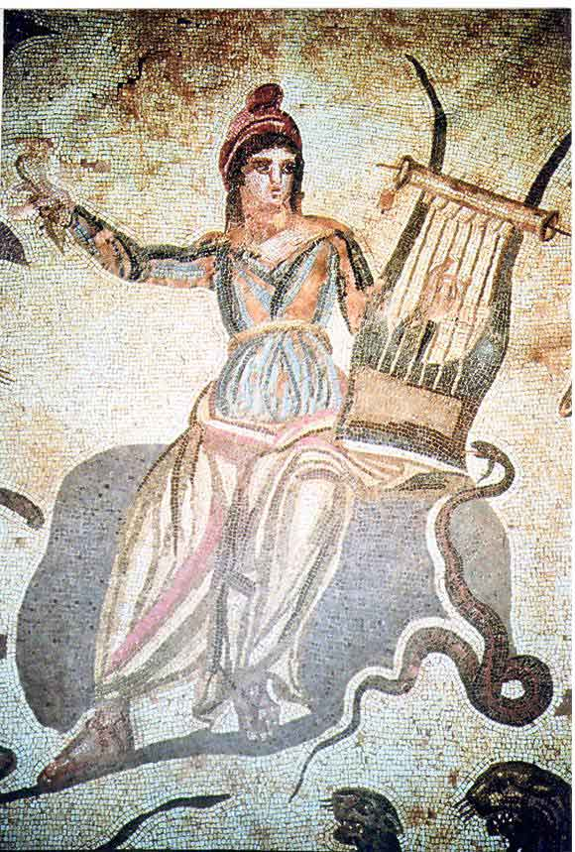
LIMASSOL MEDIEVAL CASTLE SUNDAY 18TH OCTOBER 2020
The Limassol Castle, which dates back to the Middle Ages, is located in the Old Town quarters. For a long time its mission was to protect the island from foreign raids. According to different sources, including a testimony by Etienne de Lusignan, the castle was built by Guy de Lusignan in the 12th century, while records first mention its existence in 1228.
The castle lived through several periods of reconstruction. Its current version dates back to the Ottoman period of the 19th century. Its permanent exhibition includes different objects illustrating the history of Cyprus from antiquity until the last third of the 19th century. The interior features architectural and decorative elements from different time periods.
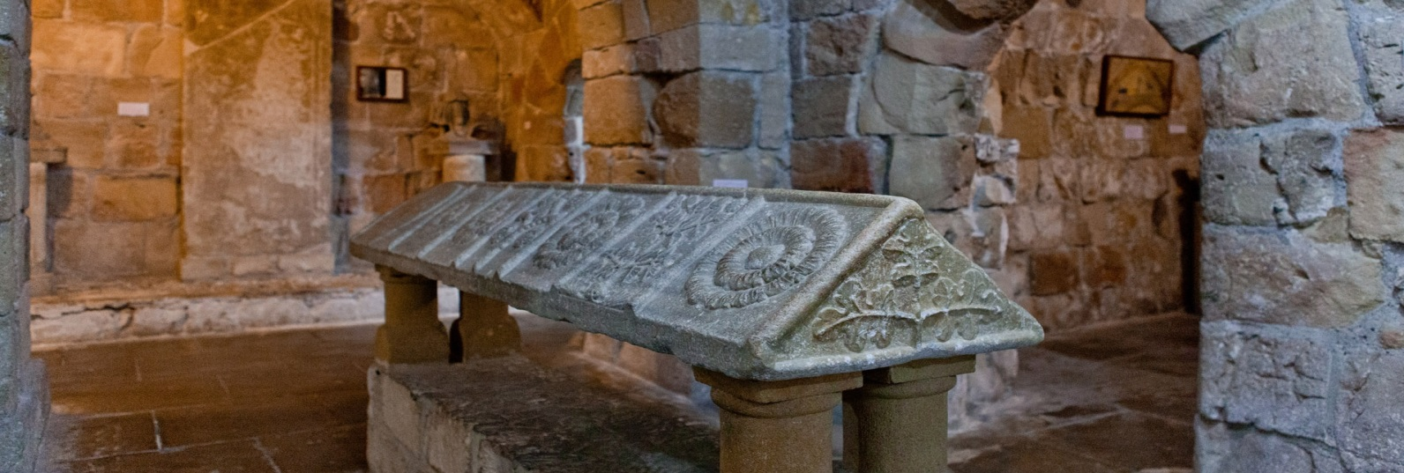
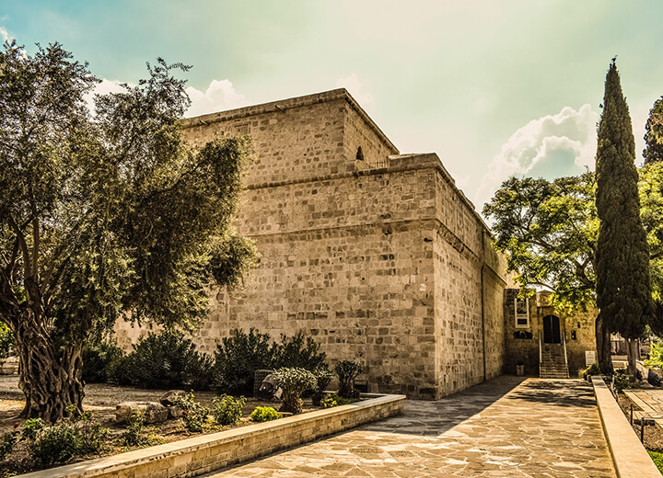
LIMANAKI Fish Restaurant
Known and acknowledged as a top fish and seafood restaurant in Cyprus for more than 30 years, Limanaki Fish Restaurant is literally only a few steps from the water, at Amathus Hotel. Its success is based on the assurance that the fish you are served in the evening was swimming in the sea that morning. Located in an idyllic landscape, the restaurant stands out thanks to the service provided, since there is an expert on hand to tell you all about the wide array of oysters, fish and other seafood on display.
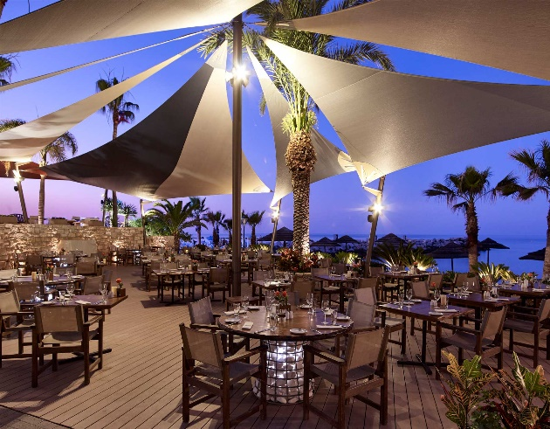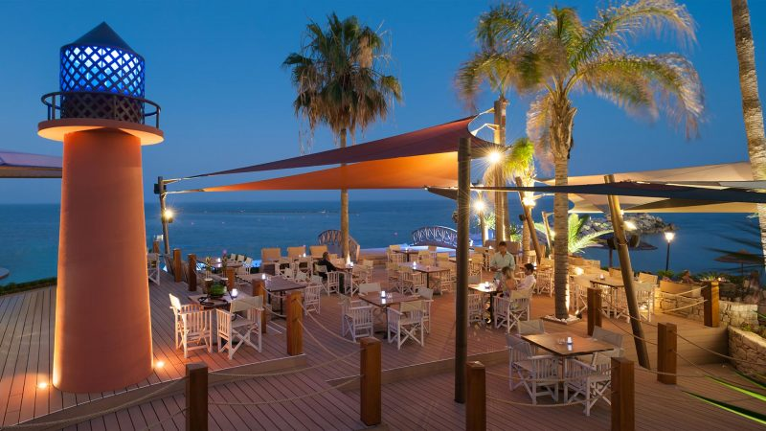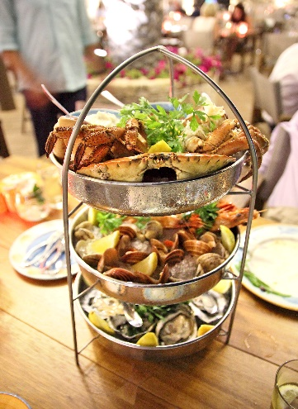

KATOI Restaurant
Situated in the heart of the picturesque village of Omodos , the Katoi Restaurant is housed in one of the oldest buildings on Omodos. The large arches of its dining area, the curved stones on the walls and the old fireplace create a traditional atmosphere, while the décor signifies the medieval heritage of the village. The cellar is even more unique, presumably constructed approximately 500 years ago. This environment is a perfect fit for the culinary experience by the restaurant. A large range of creative options, based on Greek and Cypriot cuisine aim to pleasantly surprise guests.
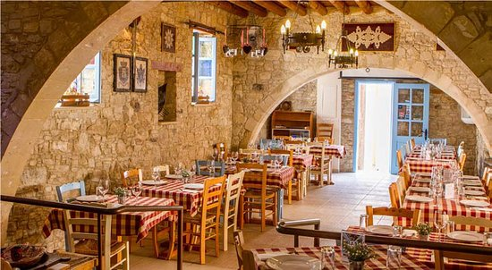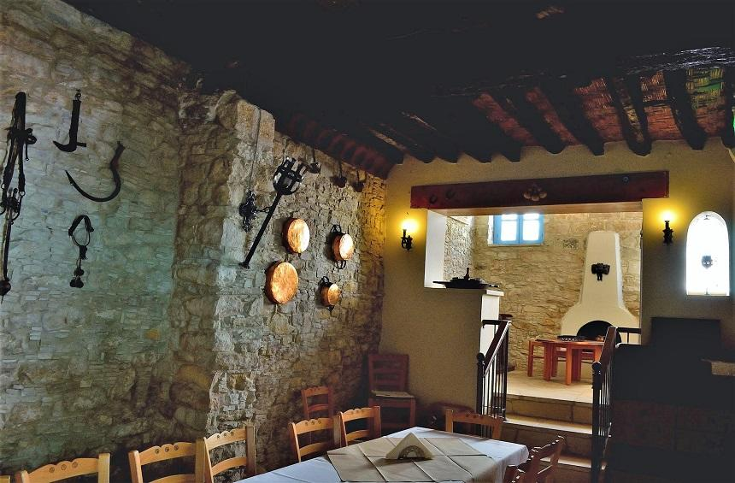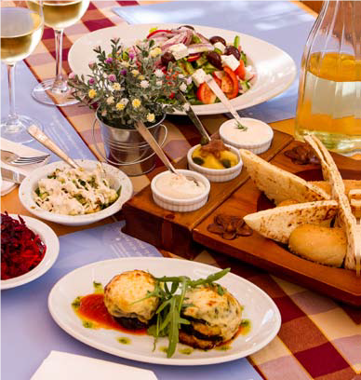

FOUR SEASONS HOTEL *****
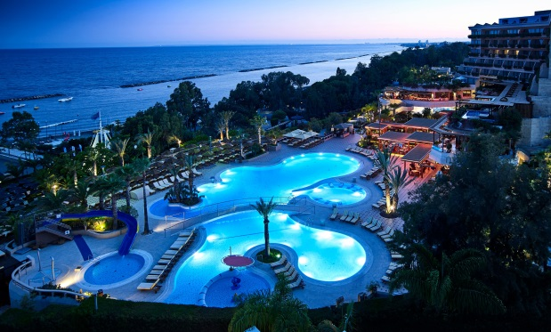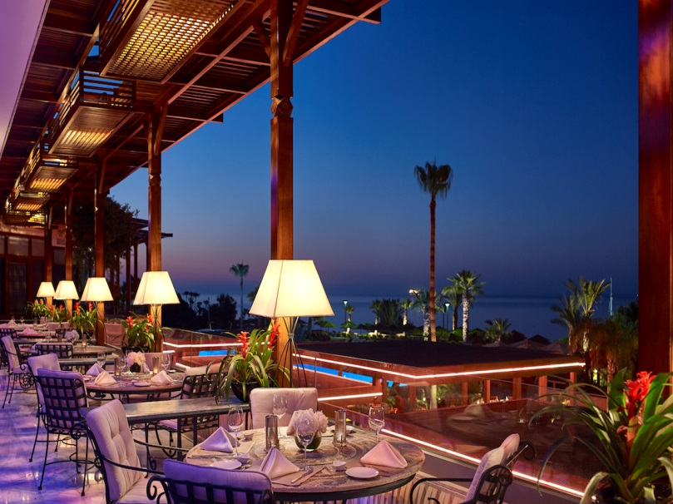
The prestigious independently owned and operated Four Seasons Hotel lies on a sandy beach east of Limassol approximately midway between the airports of Larnaca and Pafos and only a few minutes drive from the city centre. This five-star luxury hotel in Limassol is the pinnacle of luxury & style, combining impeccable facilities with world class hospitality and service, Ag. Tychonas Limassol 3313, CYPRUS.
Tel: +357 25 858 000 Fax: +357 25 310 887.
enquiries@fourseasons.com.cy reservations@fourseasons.com.cy

Superior Inland View Room – single occupancy €220.00
Superior Inland View Room – double occupancy €300.00

Superior Sea View Room – single occupancy €280.00
Superior Sea View Room – double occupancy €395.00

The above rate is quoted in Euros, per room, per day and includes full buffet breakfast, all applicable taxes

PAYMENT & CANCELLATION POLICY FOR ACCOMMODATION
The accommodation cost and extras incurred during the delegates stay in the Hotel is agreed to be settled by each delegate prior to departure from the hotel.
Any cancellations less than 2 days (48 hours) prior to arrival or No Show 100% cancellation fees will apply

PAYMENT INSTRUCTIONS
Kindly be advised that it is our policy to receive full prepayment prior to the guests’ arrival in order to guarantee the reservation. Should you wish to make your prepayment with a credit card, a separate E-mail will be sent to you from our JCC Smart Secure Payments Service.
The above process will protect and guarantee the privacy and confidentiality of the cardholder’s data and provide enhanced security for all cardholders.
Alternatively, you are also able to pay with a Bank Transfer.

CHECK IN & CHECKOUT
Kindly be informed that the normal check in time is at 14:00 hrs and the checkout time is at 12:00 hrs. The rooms will be reserved from 14:00hrs.
15 days before arrival of the guests, the Hotel must have receive:Arrival and departure times or estimate arrival/departure times in the hotel and full flight details, if applicable.
AMATHUS HOTEL *****
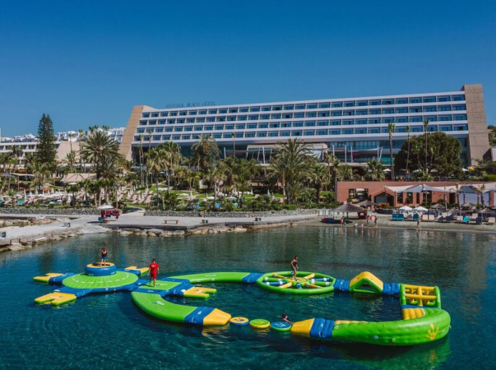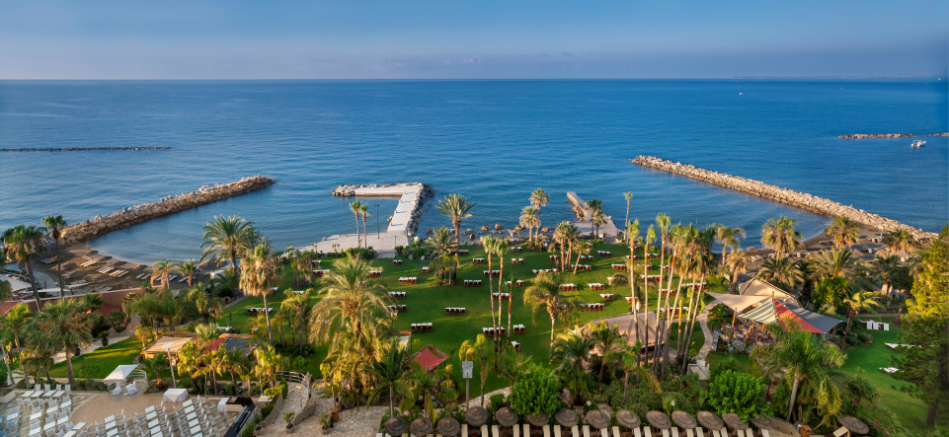
Brilliantly nestled amidst the azure of the Mediterranean and the gracious nature, the 5 star Amathus beach hotel in Limassol is a holiday sanctuary for discerning travellers seeking for a tranquil escape. Set right next to the beach this world-class hotel is a relaxing retreat for individuals of world-class status. A member of the Leading Hotels of the World, 75 Amathounta Avenue, 4532 Limassol, Cyprus
T: (+357 – 25) 832000 F: (+357 – 25) 832540
E: amathusl@amathushotel.com
Superior Inland View Room – single occupancy €180.00
Superior Inland View Room – double occupancy €232.00

Superior Sea View Room – single occupancy €227.00
Superior Sea View Room – double occupancy €320.00

The above rate is quoted in Euros, per room, per day and includes full buffet breakfast, all applicable taxes.

PAYMENT & CANCELLATION POLICY FOR ACCOMMODATION
The accommodation cost and extras incurred during the delegates stay in the Hotel is agreed to be settled by each delegate prior to departure from the hotel.
Any cancellations less than 2 days (48 hours) prior to arrival or No Show 100% cancellation fees will apply
PAYMENT INSTRUCTIONS
Kindly be advised that it is our policy to receive full prepayment prior to the guests’ arrival in order to guarantee the reservation. Should you wish to make your prepayment with a credit card, a separate E-mail will be sent to you from our JCC Smart Secure Payments Service.
The above process will protect and guarantee the privacy and confidentiality of the cardholder’s data and provide enhanced security for all cardholders.
Alternatively, you are also able to pay with a Bank Transfer.
CHECK IN & CHECKOUT
Kindly be informed that the normal check in time is at 14:00 hrs and the checkout time is at 12:00 hrs. The rooms will be reserved from 14:00hrs.
15 days before arrival of the guests, the Hotel must have receive:
Arrival and departure times or estimate arrival/departure times in the hotel and full flight details, if applicable.

20 th Anniversary
International Grand Chapitre
October 16th -18th , 2020
Important: Deadline for registration September 15th, 2020

PROGRAM

Friday, October 16th, 2020
08:30 Departure from Four Seasons Hotel or Amathus Hotel
Dress Code: Casual with comfortable shoes
09:15-10:00 Visit a factory of traditional sweets
10:30-11:15 Visit Trooditissa Monastery at Troodos mountain
11:45-12:45 Visit Omodos Village
12:45 Lunch at Tavern Katoi
14:45-15:45 Wine tasting at Vlassides Winery
16:30 Back to Four Seasons Hotel

20:00 Welcome Reception at Amathus Hotel
20:30 Diner at Amathus Limanaki Fish Restaurant
Dress code: Smart casual with CHAINE RIBBON

Saturday, October 17th, 2020
08:30 Departure from Four Seasons Hotel or Amathus Hotel
Dress Code: Casual with comfortable shoes
09:00-10:30 Tour at ancient Curium Theatre
11:00-12:30 Tour at Paphos Mosaics
12:30-14:00 Lunch at Theo’s Seafood Restaurant
15:00 Back to Four Seasons Hotel

19:15 Induction of promoted and new Chaîne members at Four Seasons Hotel
Dress code: Black tie/Tuxedo for gentlemen, evening dress for ladies, with CHAINE RIBBON
20:00 Reception at Four Seasons Hotel
20:30 Gala Dinner at Four Seasons Hotel

Sunday, October 18th,2020
09:30 Departure from Four Seasons Hotel or Amathus Hotel
10:00-11:45 Walking Tour of Limassol City Centre. The tour will include the visit of the Limassol Castle, the old market and the Limassol Marina.
12:00-13:30 Lunch at Karatello Restaurant
Dress Code: Casual with comfortable shoes

Registration, Reservation & Payment Form
Important: Deadline for registration September 15th, 2020
Name / Surname:
Member of Bailliage: |  |  |  |  |  |  |  |  |  | Nationality:
Rank in the Chaîne:
Accompanying Person:  Name/Surname: |  |  |  |  |  |  |  |  |  | Chaîne Member: YES / NO
Address:
E-mail:
Telephone:
Mobile:
 |  |  |  |  |  | PROGRAM
Date |  |  | Events |  |  | Cost per person € | Number of Participants |  |  | TOTAL €
Friday
16 OCT 2020 |  |  | Mountain Sightseeing |  |  | 75,00
08:30-16:30
Friday
16 OCT 2020 |  |  | Dinner at Limanaki |  |  | 110,00
20:00-23:30 |  |  | Fish Restaurant
Saturday
17 OCT 2020 |  |  | Paphos Archeological |  |  | 90,00
08:30-15:00 |  |  | Tour
Saturday
17 OCT 2020 |  |  | Induction Ceremony |  |  | 160,00
19:15-24:00 |  |  | and Gala Dinner
Sunday
18 OCT 2020 |  |  | Limassol Old Town Visit |  |  | 60,00
09:30-14:00
Registration fee per person |  |  |  |  |  | 30,00
 |  |  |  |  |  |  | TOTAL

TERMS OF BOOKING

Accomodation :
Hotel reservations and payments to be made directly with the Grand Chapitre’s two official Hotels:
-Four Seasons Hotel
-Amathus Beach Hotel
You are kindly requested to send us a copy of your booking confirmation.

Dinners and excursions reservation and cancellation:
Reservations are confirmed once payment is received. No penalty will be applied for any dinner or excursion cancellations made on or before September 15, 2020, while those made on or after September 16, 2020 will be subject to 100% Penalty. Any registration requests after the closing deadline will be accepted based on availability.
For more information and/or clarification please call +00357 -25736220 or send to Chaîne des Rôtisseurs P.O.BOX 50479, 3605 Limassol, Cyprus or send an email to info@chainecyprus.com

Payment Method:
By: Bank Transfer
Bank: Bank of Cyprus
Branch: 331
Account Name: Chaine des Rotisseurs
Account No. 0331-01-080876
IBAN CY94002003310000000108087600
Swift Code: BIC BCYPCY2N

By signing this document, I acknowledge and agree to the terms written above

Date (D/M/Y): ______________________

Signature: _________________________

Please fill the form on page no.13 sign page no.14 and send it by email to: info@chainecyprus.com

